Telescope Autofocuser

Camille Watson

Joseph Basdeo

Albin Myscich

Alonna Too-Chiobi

**Concept of Operations**

REVISION – Draft

8 February 2022

Concept of Operations

for

Telescope Autofocuser

Team 6

Approved by:

_____________________________

Project Leader Date

_____________________________

Prof. Kalafatis Date

_____________________________

T/A Date

**Change Record**

| **Rev.** | **Date** | **Originator** | **Approvals** | **Description** |
| --- | --- | --- | --- | --- |
| **Draft** | 2/8/22 | Telescope Autofocuser Team |  | Draft Release |

**Table of Contents**

**Table of Contents I**

**List of Tables** **II**

**List of Figures** **III**

**1.** **Executive Summary 1**

**2.** **Introduction 2**

2.1. Background 2

2.2. Overview 2

2.3. Referenced Documents and Standards 2

**3.** **Operating Concept 3**

3.1. Scope 3

3.2. Operational Description and Constraints 3

3.3. System Description 3

3.4. Modes of Operations 3

3.5. Users 3

3.6. Support 3

**4.** **Scenario(s) 4**

4.1. Deep Space Images Requiring Long Exposures 4

4.2. Low Performance of the Human Eye 4

4.3. Offset Temperature Related Contractions 4

4.4. Introduction for Amateur Astrophotographers 4

**5.** **Analysis 4**

5.1. Summary of Proposed Improvements 4

5.2. Disadvantages and Limitations 4

5.3. Alternatives 4

5.4. Impact 4

**List of Tables**

| Model Number | 6F5N |
| --- | --- |
| Telescope Series | Apertura Newtonian |
| Focal Ratio | f/5 |
| Optical Design | Newtonian Reflector |
| Telescope Aperture | 152.4mm (6”) |
| Telescope Mount Type | No Mount - OTA Only |
| Type of Electronics | OTA Only - No Electronics |
| Focal Length (mm) | 762 |
| Secondary Mirror Central Obstruction | 2” Diameter |
| Focuser Style | Crayford/Crayford Style |
| Focuser Size | 2” |
| Focuser Speed | Single Speed |
| Telescope OTA Length (in.) | 27 |
| Telescope OTA Weight (lb.) | 10.2 |

*Table 1*

**List of Figures**

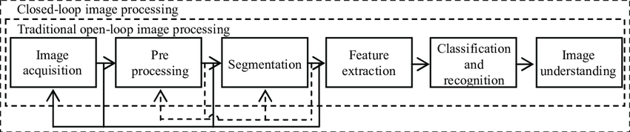

*Figure 1*

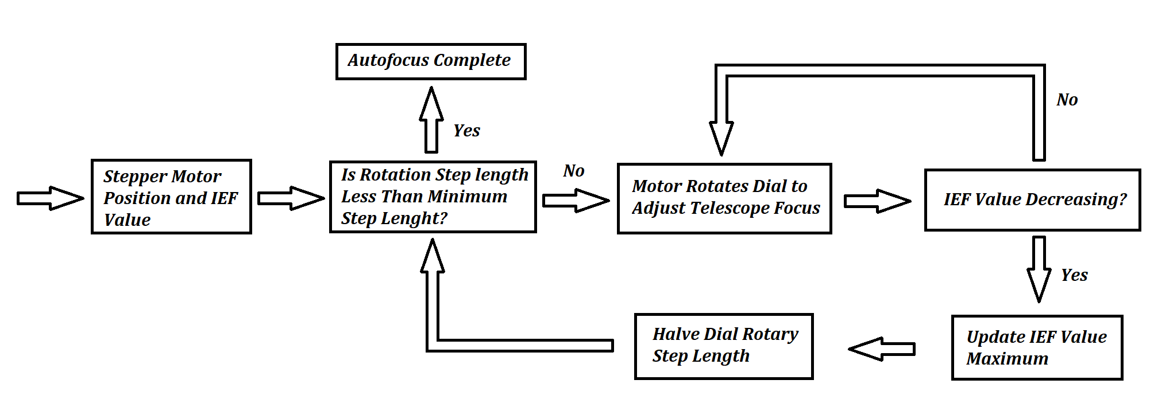

*Figure 2*

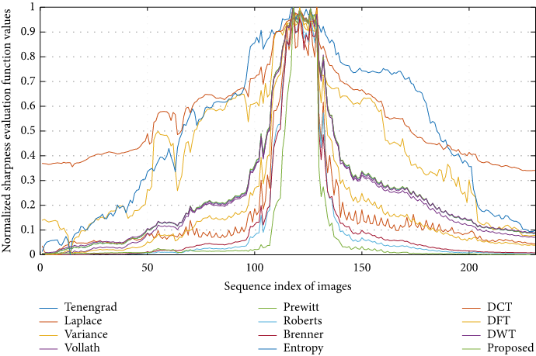

*Figure 3*

# 

# 

# Executive Summary

Due to the rise of technological advances, the action of automating machinery has become a goal for most of our current technology. More specifically, astrophotography equipment, such as telescopes, have been enhanced to include autofocusing components, although most standard telescopes do not include this feature.

Our goal is to develop a telescope capable of automatically focusing on an object of interest. The Autofocusing Telescope will achieve this aim by utilizing a combination of motors, an astro analyzer, and an image capture/processor that will be able to focus, adjust, and capture a detailed image of the object of interest. The Telescope Autofocuser will save astronomers time by providing users with the ability to quickly/effortlessly obtain detailed images of their celestial target. To produce the best picture, we will improve the detail and increase light intensity of the image via image processing.

This device will reduce the astrophotography learning curve and encourage more individuals to embrace this hobby.

.

# Introduction

In the sphere of astrophotography, observing natural phenomena are often recorded with digital images which are taken with an extreme zoom via telescope. A common issue centered around low brightness of an image is the result of telescopic zoom and the telescope’s large focal ratios; therefore, it is challenging to adapt the focus to achieve sharper images. Observatories often have the advantage of advanced instruments to aid in mitigating this known problem with celestial imaging. However, hobbyists and members of the amateur astrophotography community frequently experience these problems and get low quality images as a result.

For the duration of the project, we plan to completely implement a coupled autofocusing module from which the telescope can achieve optimal sharpness when capturing an image. Since traditional methods of manual focus control offered by telescope producers aren’t adequate for quality imaging, we plan to implement more intelligent imaging and focusing methods. The system consists of a pinion and rack focuser which is operated by a set of servos. Moreover, the image raster processing consists of intelligent real-time and post-processing models with the help of machine learning. Images are captured with a camera fastened to an eyepiece. To tie all components together, a cheap development board will be used to process images and optimize focus quality.

## Background

Current telescope-based autofocus methods are split into two categories; passive and active autofocus.

The passive autofocus method is further partitioned into two separate categories known as contrast and phase detection. Phase detection autofocus can be examined where the received light ray is separated into two. Here, the hardware possesses micro lenses which contain separate image recorders; when the sensor finds that the image is focused, the recorder hardware will receive near-indistinguishable images. Alternatively, the technique involving contrast detection scans each pixel where the difference is assessed based on a consecutive set of images. As a result, the frame with the most contrast (most focused image) is algorithmically selected.

On the other hand, to employ an active autofocus technique, a measuring device is commonly used to determine range. These devices include but are not limited to infrared reflection and ultrasonic sound waves. Of course, each has their own set of benefits and limitations. In any case, the device determines the span between the target object and the affixed camera. Specifically, the algorithm calculating the distance will set the position of the lens. As a result, a focused image with a sharp contrast can be pipelined from the camera.

Imaging using high magnification and gradient-based contrast has an exceptional capacity for optimizing sharpness as opposed to algorithms dependent on edges, transforms, statistics, and correlation calculations. This concept explores gray coloration differences in adjacent pixels, which represent image sharpness. Examples of this raster image processing include popular models such as the Hemli and Scherer's mean (HSM), Tenengrad (TGR), and Gaussian derivative (GDR) with the assistance of Sobel operators or Laplacian filters. Each of these methods make for great options for boosting the quality of gradient-based measurements.

## Overview

The primary focus of the Telescope Autofocuser is to replace manually configuring the focal setting and image processing with an automated medium. As a preface, the project takes influence from most modern observatories that use a series of sophisticated techniques to optimize image quality. Despite the fact that Based on discussion and initial designs of the model, the apparatus is divided into three separate parts; eyepiece interface, dial manipulation, and image processing.

If a camera sensor is placed outside the focal plane of an ocular system, only a defocused picture with distorted boundaries can be recognized. Considering the frequency domain, high-frequency components of an image with distinctive shapes are filtered out as a result of the low-pass characteristics of the system’s received frequencies. In order to take a clear image, the main notion of the autofocus equipment is to regulate the lens position in the system so that the camera is optimally positioned at the focal plane. From here, ample number of high-frequency elements are received to identify a definite contour of an image’s boundaries. In most digital image processing techniques, a high-frequency filter is used to obtain the high-frequency components of the fast Fourier transform results of the image. If the scales of related high-frequency factors are larger than some present values, then the image is deemed as sufficiently sharp.

Based on the Apertura Newtonian 6F5N telescope system, it was investigated, as shown in Table 1. The basic system mainly consists of its parabolic primary mirror, white OTA, 2 inch Crayford-style focuser, f/5 focal ratio, and dovetail plate. It’s important to note that the bare system contains no external electronics and must require specialized components to fit the design. External components will include, a PC management, stepper motors, breakout camera, and mechanical manipulation apparatus. To enhance the quality of captured images, a Schmidt corrector can be installed to the telescope front; a camera with a thin frequency band filter can be applied to receive images and convolute the sieved results to the PC management board. In this component, a stepper motor is employed to adapt the position of the main image of the telescope in the controller mechanism based on the image evaluation.

Here, the auto-focus procedure can be described as beginning with the camera which captures data concerning the tracked objects with the telescope. It then transmits the image to the PC management board. Then, dev board’s software performs a calculation based on the image and directs instructions to rotate the stepper motor counterclockwise or clockwise. From here, a mechanical transformation unit will apply a rotational force into a driver that adapts the position of the telescope’s main mirror forward or backward. As a result, it will successively adjust the imaging position and focus. The processes described are ultimately recurrent events until the camera recognizes the telescope’s image plane. Therefore, a clear image is then obtained, which defines this system’s schema as a closed-loop system.

Within the realm of software, the focus search algorithm, with the help of Hemli and Scherer's mean (HSM), Tenengrad (TGR), and Gaussian derivative (GDR) [Figure 3] are responsible for the focus quality and efficacy of the system. In the testing phase, the hill-climbing exploration approach can be used to accomplish a near optimal focusing effect [Figure 1, 2]. From here, the stepper motors will slowly rotate the telescope’s knob at a suitable step length to adjust the system’s focal length from which the image estimation function value is calculated to supply a constant stream of feedback. When the image estimation function begins to decrease, it implies that the optimal focusing location has been passed. As a direct response, the knob can be rotated a step in reverse. Next, the present step length is then cut in half, and the search procedure is recurred until the exploration is concluded with the lowest step size reached. As a result, the auto-focus procedure can be deemed complete.

## Referenced Documents and Standards

1. Achim Mester, "Contrast Detection Autofocus (CDAF) for Telescopes using a Stepper Motor and a Raspberry Pi" July 6, 2014
2. Mir, H., Xu, P., Chen, R., & van Beek, P. (2015). An autofocus heuristic for digital cameras based on supervised machine learning. *Journal of Heuristics*, *21*(5), 599–616. <https://doi.org/10.1007/s10732-015-9291-4>
3. Pech-Pacheco, J. L., Cristobal, G., Chamorro-Martinez, J., & Fernandez-Valdivia, J. (n.d.). Diatom autofocusing in Brightfield Microscopy: A comparative study. *Proceedings 15th International Conference on Pattern Recognition. ICPR-2000*. <https://doi.org/10.1109/icpr.2000.903548>
4. Vaquero, D., Gelfand, N., Tico, M., Pulli, K., & Turk, M. (2011). Generalized autofocus. *2011 IEEE Workshop on Applications of Computer Vision (WACV)*. <https://doi.org/10.1109/wacv.2011.5711547>
5. Yao, Y., Abidi, B., Doggaz, N., & Abidi, M. (2006). Evaluation of sharpness measures and search algorithms for the auto focusing of high-magnification images. *SPIE Proceedings*. <https://doi.org/10.1117/12.664751>
6. Śliwiński, P., & Wachel, P. (2013). A simple model for on-sensor phase-detection autofocusing algorithm. *Journal of Computer and Communications*, *01*(06), 11–17. <https://doi.org/10.4236/jcc.2013.16003>
7. Mateos-Pérez, J. M., Redondo, R., Nava, R., Valdiviezo, J. C., Cristóbal, G., Escalante-Ramírez, B., Ruiz-Serrano, M. J., Pascau, J., & Desco, M. (2012). Comparative evaluation of autofocus algorithms for a real-time system for automatic detection of mycobacterium tuberculosis. *Cytometry Part A*, *81A*(3), 213–221. <https://doi.org/10.1002/cyto.a.22020>
8. Yan, X., Lei, J., & Zhao, Z. (2020). Multidirectional gradient neighbourhood-weighted image sharpness evaluation algorithm. *Mathematical Problems in Engineering*, *2020*, 1–7. <https://doi.org/10.1155/2020/7864024>
9. Grigorescu, S. M., Ristić-Durrant, D., Vuppala, S. K., & Gräser, A. (2008). Closed-loop control in image processing for improvement of object recognition. *IFAC Proceedings Volumes*, *41*(2), 5335–5340. <https://doi.org/10.3182/20080706-5-kr-1001.00899>
10. UNIVERSITATIS, FACTA & Ristic-Durrant, Danijela & Graeser, Axel. (2022). CLOSED-LOOP CONTROL OF SEGMENTED IMAGE QUALITY FOR IMPROVEMENT OF DIGITAL IMAGE PROCESSING UDC 62-52:004.932.

# Operating Concept

## Scope

The Telescope Autofocuser will increase the efficiency of stargazing by providing users with the ability to automatically focus on their star of interest and capture detailed images. Once the user has identified their star of interest, the telescope will then feed this image to an analyzer that communicates with motors to control the focus of the telescope. Once the analyzer has determined that the image is in focus, multiple images will then be captured and processed in order to produce a detailed picture of the star of interest. For demonstration and testing purposes, the telescope will be mounted in a room and a static image will be placed some distance away. While there are many telescopes on the market, the Telescope Autofocuser will replace the archaic action of having to manually focus your device. Not only will this benefit astronomers who don’t have the time to manually adjust their telescope, but it will also benefit those who are beginners in stargazing.

## Operational Description and Constraints

The Telescope Autofocuser is intended to be used by astronomers or those who have an interest in astronomy and would like to quickly/effortlessly obtain detailed images of their object of interest. An astro analyzer will be attached to the telescope’s eyepiece and a motor(s) will be attached to the telescope’s focus knobs. Once the telescope has been directed towards the object of interest, the astro analyzer will begin examining the clarity of the object. Depending on the clarity level, the analyzer will communicate with the motor(s) to adjust the focus of the telescope until the analyzer is satisfied with the object’s clarity. Multiple snaps of this image will then be captured and sent to a program where it will be processed in order to improve the light intensity and detail of the object.

Based on this operational description, possible constraints include:

1. The motors must be mounted to the body of the telescope in a way that does not affect the telescope's vision.
2. The astro analyzer must be fastened to the eyepiece of the telescope so that it virtually prevents any movement and could block the user from peering into the telescope. Here, reliance on an external monitor might be necessary (assuming the project isn’t [headless](https://en.wikipedia.org/wiki/Headless_computer)).

## System Description

1. Telescope: The telescope will be the body of the product as well as the subsystem responsible for identifying objects of interest. It will consist of the following components: the outer shell, eyepiece, lenses, mirrors, and a structural support. The telescope will provide our system with the ability to identify long range objects of interest to be focused on, captured, and processed. In order to prevent malperformance of the telescope we will avoid tampering with the inside.
2. Astro Camera (Analyzer): The astro analyzer will be responsible for determining if the object of interest is in focus. It will consist of a camera lens (responsible for perceiving the image) and an analyzer (responsible for determining the resolution of the image). This subsystem will give the product its main selling ability, which is auto-focusing. To prevent faulty analysis, the lens of the analyzer will be cleaned routinely.
3. Motors: When the system has determined that the object is not in focus, signals will be sent to the motors who are responsible for adjusting the focus knobs of the system. This subsystem will consist primarily of focus knobs and motors, and it will also provide the overall system with the ability to sharpen its focus on the object of interest.
4. Image Capture/Processing: After the system has successfully determined that the object of interest (OI) is in focus, the image capture/processing subsystem will then capture multiple snaps of the same image and process them in order to increase the light intensity of the image and improve overall clarity. This subsystem will provide the user with a detailed picture of the object of interest.

## Modes of Operations

The Telescope Autofocuser will have one mode of operation which we will call “automatic”. In this mode, the user will point the telescope in a general direction and select the OI to be focused on; else, the system will not begin focusing. In this mode of operation, the telescope will feed the image to an analyzer that communicates with motors. These motors will have control over the focus of the telescope. Once the analyzer has determined that the image is in focus, multiple images will then be captured and processed in order to produce a detailed picture of the object of interest.

## Users

Our autofocusing system will be primarily marketed to astronomers and those interested in astronomy who want to capture high quality images of celestial objects. This product will reduce the time and effort needed to clearly identify an OI and it will do so with minimum user experience.

The Telescope Autofocuser could also be utilized by ships through installing the system on the upper deck to identify unknown vessels far out into the sea and prevent possible collision.

## Support

Support for the Telescope Autofocuser will be provided in the form of a detailed user’s manual. The manual will consist of instructions on how to set up the system, usage, and maintenance.

# Scenario(s)

* 1. ***Deep Space Images Requiring Long Exposures***

Deeper space images require longer exposure time, so manual refocusing is typically required every 5 to 10 minutes. To avoid the precision and consistency needed in manual refocusing, the Telescope Autofocuser will aid the user in automatically capturing and focusing long exposure images.

## Low Performance of the Human Eye

The human eye is often not capable of quality optical performance in low intensity light. The Telescope Autofocuser utilizes an imager that is capable of capturing these low light images. In addition, the telescope will assist users with focusing in low light and producing astronomical images that a human eye cannot view naturally.

## Offset Temperature Related Contractions

Telescope usage is often utilized during the evening and night time where temperatures begin to decrease. Critical components of the telescope, such as the optical tube assembly and focuser drawtube, will contract due to the lower temperatures. The Telescope Autofocuser will assist by autofocusing, relieving the user of manually refocusing the telescope to offset the temperature changes.

## Introduction for Amateur Astrophotographers

In astrophotography, manual focus is a skill that is learned over time with an abundance of image capturing. Beginners in this field that desire high quality images with minimal experience can use the Telescope Autofocuser to ensure the same quality image capturing as taken by an experienced astrophotographer.

# Analysis

## Summary of Proposed Improvements

* An imager positioned on the eyepiece of the telescope. The imager will be capable of capturing images in low light intensity.
* A mounting system that is capable of attaching to an Adventura Newtonian Telescope without damaging any of the autofocusing instruments as well as the telescope’s body.
* A stepper motor assembly will rotate a crayford focuser to achieve a focused image.
* An automated software solution will be applied to capture images in real-time and in post-processing. Here, machine learning will be leveraged to optimize the live feed of captured images. However, a more primitive, but effective implementation will stack multiple images into a final photo. Both methods offer effective ways to optimize the desired results.
* Autofocus techniques involving heuristic raster processing will allow the telescope controls to seek out an optimal contrast. In order to ensure quality image capture and performance, real-time processing techniques will offer excellent results for time-critical tasks.

## Disadvantages and Limitations

The Telescope Autofocuser will have limitations that include:

* The assembly which is designed to work with the sizing and constraints of an Apertura Newtonian Telescope. It will not be able to cross different product types and brands if desired.
* The medium capturing images will need a sufficient level of contrast lighting in order to adequately adjust the telescope dials. Adjusting the dials will cause the feedback loop to sharpen captured images. For a distant, or dimly lit target, this can be challenging to achieve.
* The product will only perform well in standard telescope observing conditions, such as skies with limited visible clouds, low humidity levels, and minimal to no dust concentration.
* Design, prototyping, and fabrication must be operated within a finite budget.

## Alternatives

* A sensor that when perceiving a focused image will signal the user either audibly or visually to stop manually rotating the crayford focuser. Unlike our proposed solution, this requires the user to be more involved in the focusing process. This solution will better suit users that want more handle in the process, and can enable them to make slight adjustments that would not be capable in our solution.

## Instead of using an imager, a solution would be to attach a standard camera to the telescope eyepiece. The user can utilize in-built focus and zoom settings to get a desired image. Negative aspects in this solution include that there is no post processing for a better quality image.

* Purchasing a built in autofocusing feature on a new telescope; however, this is a far more expensive approach than our proposed solution that will be functional for the same needs of the consumer.

## Impact

Our Telescope Autofucuser will impact the following:

* **Astrophotography Community** The ability to autofocus on an object of interest will reduce the astrophotography learning curve which in turn will bring more individuals into the astrophotography community. This will have a positive effect on the astronomy industry/market.
* **Image Quality** The autofocuser will reduce human error when capturing images. In turn, the images that use this product will be clearer and more accurate, which can help astrophotographers retrieve proper data and reduce the number of wasted captures. To add, cheaper (and more accessible) hardware can leverage autofocus modules which in turn produce similar results to more expensive telescope models.
* **Open Source Contributions** Since the growth of amature engineers and hobbyist are increasing every year, providing a significant contribution to the “hacker” community would likely foster positive engagement. By offering free and open source software and hardware solutions, project traction has a high chance of improving with regard to security, material needs, efficiency, and quality. As opposed to hidden proprietary solutions, open source offers more aspects of digital freedom to circulate popular implementations.
* **Ethical Concerns** In an era where privacy and control over personal devices is a desired trait, most modern devices appear to fall short in offering open access to the owners of said devices. Despite the fact that the code and designs implemented will be free and open source, the device’s application to the machine will likely make it difficult to use once mounted. With this in mind, we plan to offer a “hands-on” mode, but this will likely be impeded by the devices.
* **Security Concerns** It’s important to note that every device is imperfect and likely has an unknown (or known) security exploit. Specifically, development boards such as Raspberry Pis, Arduino’s, and Beagle Bones are infamous for their exploitability as a victim machine; the more features on the board, the more exploitable it becomes. Despite our best efforts to make the application secure, the hardware or embedded software has the potential to reveal user information.